LOBULATED TONGUE- A RARE DEVLOPMENTAL ANOMALY
- Dr Supratim Ghosh*, Associate Professor, Dept. Of Dentistry,
College of Medicine and Sagore Dutta Hospital, Kamarhati, Kolkata-58,WB.
- Dr. Debasish Pramanick, Dental Surgeon, department of oral pathology
Burdwan Dental College and Hospital, Dist.- East Burdwan,WB.
corresponding author: Dr Supratim Ghosh E-mail id: drsupratimg@gmail.com
ABSTRACT
Lobulated tongue is a relatively uncommon congenital anomaly characterized by one or multiple elevations and/or indentations on the edge or surface of the tongue, resulting in an irregular contour. This condition is considered a rare occurrence in the spectrum of human congenital anomalies, and it may present as an isolated case or be associated with syndromes, co-existing with hamartomas or teratomas.Various syndromes have been identified in association with lobulated tongue, underscoring the diversity of its manifestations within the medical realm. Examples of such syndromes include Tessier type 30 craniofacial cleft, Oral-Facial-Digital Syndrome (OFDS), Opitz G BBB syndrome, Klippel–Feil anomaly, and Larsen syndrome. These syndromes contribute to the complexity of lobulated tongue cases, emphasizing the need for a thorough examination and diagnostic approach.
A noteworthy aspect of lobulated tongue development lies in its origins during the fusion of two lateral lingual swellings and the tuberculum impar. Any disturbance or alteration in this intricate fusion process can give rise to the characteristic irregularities observed in a lobulated tongue. Understanding the embryological basis of this condition is instrumental in elucidating its etiology and guiding appropriate interventions.Early diagnosis and timely treatment of lobulated tongue are pivotal in preventing potential difficulties in swallowing and speech. As with many congenital anomalies, intervention at an early stage can significantly impact the overall prognosis and quality of life for affected individuals. The treatment protocol often involves surgical correction to address the physical abnormalities associated with the condition.In the case presented in this article, a 19-year-old female patient exhibited an isolated lobulated tongue. This underscores the importance of recognizing and documenting individual cases to contribute to the collective knowledge base and facilitate a deeper understanding of the clinical spectrum of lobulated tongue presentations.
In conclusion, lobulated tongue, while a quiet rare congenital anomaly, warrants careful consideration due to its potential association with syndromes and the impact it can have on speech and swallowing. Continued research and case studies, such as the one described here, contribute to the evolving understanding of this condition and inform strategies for early diagnosis and effective intervention

KEYWORDS: Lobulated tongue, Bifid tongue, Tongue developmental anomaly, Oral facial Digital syndrome, Tessier type 30 craniofacial cleft.

INTRODUCTION
Lobulated tongue, a rare and congenital developmental anomaly, manifests as one or multiple elevations and/or indentations on the edge or surface of the tongue, resulting in an irregular contour. This condition is often referred to in the literature as accessory tongue, bifid tongue, double tongue, or cleft tongue. While the latter is a physiological feature observed in many reptiles, aiding them in chemosensation and smell, the presence of a lobulated tongue in humans constitutes a developmental malformation.[1]
The rarity of lobulated tongue makes it a notable congenital anomaly in the human population. It may occur in isolation or be associated with syndromes, or coexist with hamartomas or teratomas. Notable syndromes linked to lobulated tongue include Tessier type 30 craniofacial cleft, Oral-Facial-Digital Syndrome (OFDS), Opitz G BBB syndrome, Klippel–Feil anomaly, Larsen syndrome, and its occurrence has also been noted in children born to diabetic mothers.[2]
The tongue, a highly vascular and muscular organ, serves a myriad of physiological functions. The dorsum of the tongue plays a crucial role in taste sensation, temperature perception, pain response, and tactile information. Additionally, it is integral to the mixing and propulsion of the food bolus towards the oropharynx, facilitating the process of deglutition. Among its functions, phonetic articulation stands out as a vital aspect.[3]
However, the presence of a lobulated tongue introduces challenges in various aspects of life. Infants born with this condition may encounter difficulties in suckling, affecting their ability to feed effectively. Swallowing becomes a complex task, and speech articulation may be compromised. Furthermore, individuals with a lobulated tongue are at an increased risk of trauma during mastication, adding another layer of complexity to their daily lives.[4]
This article presents a unique case of lobulated tongue accompanied by certain dental abnormalities. Notably, in this particular case, no syndrome was identified as being associated with the lobulated tongue. This emphasizes the variability and diverse clinical presentations of this congenital anomaly.[5]
The comprehensive assessment of the patient revealed not only the lobulated tongue but also specific dental irregularities, highlighting the importance of a thorough examination for a comprehensive understanding of the clinical picture. The absence of an associated syndrome in this case underscores the complexity and diversity within the spectrum of lobulated tongue presentations.[6]
In conclusion, lobulated tongue represents a fascinating yet challenging congenital anomaly. Its rarity, association with syndromes, and impact on crucial physiological functions necessitate a multidisciplinary approach to diagnosis and management. Understanding the diverse manifestations and potential associations, as demonstrated in this case, contributes to the evolving knowledge of lobulated tongue and informs tailored interventions for affected individuals[7]

CASE REPORT
A 19-year-old female patient reported to a tertiary health care centre with a chief complaint of abnormal appearance of tongue along with speech difficulty. Her medical history, family history, personal history was nothing significant.
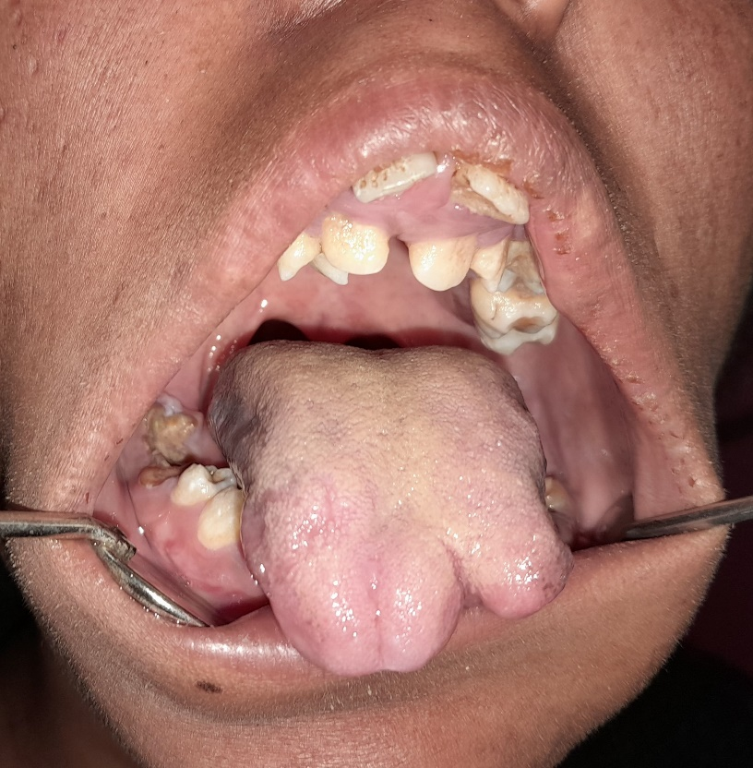
Figure 1 : Intraoral photograph showing lobulated tongue.
Upon conducting a comprehensive evaluation of the patient, it was observed that the individual possessed an average physique, and all vital signs fell within the parameters of normalcy. During the examination of external facial features, it was noted that the lips exhibited incompetence. Further scrutiny within the oral cavity revealed a distinct dental condition characterized by the proclination of the maxillary anterior teeth, a visual representation of which can be found in Figure 1. Notably, an additional finding in the intraoral examination was the presence of a lobulated tongue, adding complexity to the clinical presentation.[8]
It is noteworthy that the lobulated tongue, a rare congenital anomaly, was identified during this examination. This unique feature, along with the dental irregularities, necessitates a thorough understanding of the patient's oral and craniofacial anatomy. Despite the distinctive characteristics observed, palpation of the tongue indicated a normal consistency, underscoring the need for a multifaceted approach to diagnosis and treatment planning. The amalgamation of these findings highlights the importance of a holistic assessment to gain comprehensive insights into the patient's oral health and guide tailored interventions for optimal outcomesThe patient was referred to the concerned department for further management.[9]

DISCUSSION
Tongue development usually starts at around the 4th week of intra-uterine (IU) life in the floor of the primitive cavity from the first three or four brachial arches. The tongue connective tissue and vasculature are derived from cranial neural crest cells. And the muscles of tongue develop from the myoblasts that have migrated from the occipital somites.
Tongue arises from the tuberculum impar, a median swelling at the floor of the pharynx and two lateral lingual swellings which joins the central structure. Slowly, the two lateral lingual swellings grow towards each other and finally cover the tuberculum impar thereby forming the anterior two-thirds of tongue. Any disturbance or alteration during this event, leads to the development of lobulated tongue. In fact, any condition affecting this mesenchymal fusion occurring towards the end of 4th week IU life paves the pathway for this malformation.
Such developmental anomaly of tongue may appear as an isolated entity or may be associated with syndromes. When a patient reports with a lobulated tongue, it is important to make a differential diagnosis and also to arrive at a definitive diagnosis which would ultimately help in identification and management of the case. Detection and diagnosis of these cases as syndromic or non-syndromic is of utmost priority.
Manifestation of lobulated tongue may be multifactorial. Syndromes associated with lobulated tongue are Tessier type 30 craniofacial cleft, Oral-Facial-Digital Syndrome (OFDS), Opitz G BBB syndrome, Klippel–Feil anomaly, Larsen syndrome, Goldenhar syndrome [8], Ellis–van Creveld syndrome [9]. Child born to diabetic mothers also suffer from lobulated tongue. Piercing the tongue is another contributory factor towards formation of lobulated tongue. This present case cannot be put under any of the well-defined syndrome. Any other associated orofacial malformations, family history, genetic predisposition, postnatal trauma, tongue piercing cannot be identified in this case. So, it is considered as an isolated case of lobulated tongue.
CONCLUSION
Timely intervention for the treatment of a lobulated tongue is imperative to forestall any impediments in both swallowing and speech processes. The corrective measure involves the implementation of surgical reconstruction to address the underlying defect, followed by a comprehensive regimen of speech therapy. This dual approach not only rectifies the physical anomaly but also ensures the restoration of optimal functionality in articulation and deglutition.
The significance of addressing a lobulated tongue promptly lies in averting potential complications that may arise from difficulties in swallowing and articulating speech sounds. Failure to intervene at the appropriate time could exacerbate the challenges faced by individuals with this condition, leading to a cascade of repercussions on their overall quality of life. Therefore, an early and well-tailored treatment plan becomes pivotal in mitigating these concerns.
The surgical reconstruction of the tongue involves meticulous correction of the lobulated structure, aiming at restoring its normal anatomical configuration. This procedure is performed with precision to optimize both form and function, facilitating improved swallowing abilities and enhancing speech articulation. Post-surgery, a critical component of the holistic treatment approach involves the incorporation of speech therapy into the rehabilitation process.
Speech therapy plays a vital role in aiding individuals with a lobulated tongue to regain and refine their communication skills. Therapists employ targeted exercises and techniques to enhance tongue control, coordination, and muscle strength, thereby promoting clearer and more intelligible speech. The tailored nature of speech therapy allows for a personalized rehabilitation plan, addressing the unique needs of each individual and maximizing their potential for recovery.
In conclusion, the timely treatment of a lobulated tongue encompasses surgical reconstruction to rectify the anatomical defect, complemented by a dedicated regimen of speech therapy. This comprehensive approach not only addresses the physical aspects of the condition but also fosters the rehabilitation of essential functions, ensuring a more holistic recovery for individuals affected by this condition

REFERENCES
[1] Hiradfar M, Bakhshaee M, Shojaeian R, Zabolinejad N, Forghani M, Mirhosseini F. Accessory tongue: classification and report of a case. Int J Pediatr Otorhinolaryngol. 2015;79(8):1175-1179.
[2] Emmanouil-Nikoloussi EN, Kerameos-Foroglou C. Developmental malformations of human tongue and associated syndromes (review). Bull Group Int Rech Sci Stomatol Odontol 1992;35:5-12.
[3] Mihci E, Tacoy S, Ozbilim G, Franco B. Oral-Facial- Digital Syndrome Type 1. Indian Pediatrics 2007;44:854-6.
[4]. Orhan D, Balci S, Deren O, Utine EG, Basaran A, Kale G. Prenatally diagnosed lethal type Larsen-like syndrome associated with bifid tongue. Turk J Pediatr 2008;50:395-9.
[5] Parashar SY, Anderson PJ, Cox TC, McLean N, David DJ. Management of Opitz G BBB Syndrome. Ann Plast Surg2005;55:402-7.
[6]. Widgerow AD. Klippel-Feil anomaly, cleft palate and bifid tongue. Ann Plast Surg 1990;25:216-22.
[7] James AW, Culver K, Hall B, Golabi M. Bifid tongue: a rare feature associated with infants of diabetic mother syndrome. Am J Med Genet A. 2007 Sep 1;143A(17):2035-9.
[8] Konas E, Canter HI, Mavili ME. Goldenhar complex with atypical associated anomalies: is the spectrum still widening? J Craniofac Surg 2006;17(4):669–72.
[9] Mostafa MI, Temtamy SA, el-Gammal MA, Mazen IM. Unusual pattern of inher-itance and orodental changes in Ellis–van Creveld syndrome. Genet Couns2005;16(1):75–83.

